Name: ___________________________________________ Date: __________________________
FIND SOMEONE WHO…

What causes surface currents?  WIND | On the back of this paper, draw a picture of the moon, Earth, Sun and tides during a spring tide.  See next page… | Why doesn’t warm water on the surface sink to the bottom and mix?  Less dense = stays at the top | What causes deep currents?  Differences in density
Turnover is to lake as ________&___________ are to ocean.  Upwelling and downwelling | On the back of this paper, draw a picture of the moon, Earth, Sun and tides during a neap tide.  See next page… | Density of salt water is (>, <, =) density of fresh water.  Greater than.  More salt = more dense!  More salt = easier for things to float also! | On the back, label the ocean floor map.  See next page…
On the back of this paper, draw a picture of a wave and label the crest, wave height, wavelength, & trough  See next page… | Under which types of moons do neap tides occur? Spring tides?  Neap = 1st and 3rd quarter moons  Spring = new and full moons | Which type of tide causes more extreme high and low tides?  Spring | What is the primary way in which waves form?  WIND
What are 2 obstacles to ocean exploration?  Pressure, depth, darkness, cold (temperature)… | List the 3 temperature zones.  Epipelagic  Mesopelagic  Bathypelagic | What happens to water particles as a wave passes through?  Water particles stay in the same place – they move up and down in little circles | T/F Waves transport energy, not water  TRUE!  Waves only transport energy…NOT water.

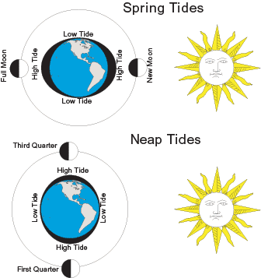
Spring and Neap tide diagram:

Wave drawing:

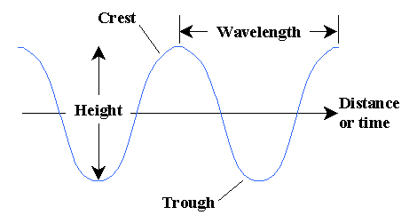

Ocean floor map:
Use the following terms:
Sea mounts Mid-ocean ridge Ocean trench
Continental Shelf Continental Slope Volcanic Islands

(ON DIAGRAM….)
- Continental shelf
- Continental slope
- Ocean trench
- Mid-ocean ridge
- Seamounts
- Volcanic islands

